**Weekly Tip – Reduce Stress and Stay Motivated**

I loved this article from pbs.org <https://www.pbs.org/parents/thrive/how-you-and-your-kids-can-de-stress-during-coronavirus>

It describes that at times, stress feels like taking a firehose to the face! It can feel overwhelming and paralyzing. These simple questions can help you de-stress!

FireHOSE – stress relief analogy.

**H – Am I Hungry**? If so, eat something healthy. During times of stress, we often forget to take care of ourselves – which is the most important thing!

**O – Am I Overstimulated**? If so, take a break – stop watching news, reading, social media, checking email or phone texts. Give yourself 10 minutes to breathe.

**S – Do I need Sleep**? Again, during times of stress, it can be hard to get enough sleep. Try tea before bed, or shut down the tech at least 30 minutes before you close your eyes. Listen to calming music instead or use a relaxation app.

**E – Do I need Exercise**? Take a walk with the family, play in the yard with the kids, find a 10-min exercise routine to do. Exercise not only makes you feel better, but helps protect you from illness and increases “happy neurochemicals.

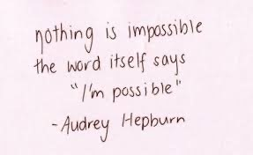 **Healthy eating, sleep, exercise** are just as important for kids as it is for adults. Just because you don’t have school, it’s not an excuse to stay up late, eat junk food, and sit around all day watching tv or youtube. The **overstimulated** part is also for you. Overstimulated basically means your brain is on overload and needs a break. Don’t stay on tech all day OR in front of the tv. Mix up your day – your body and mind will thank you for the